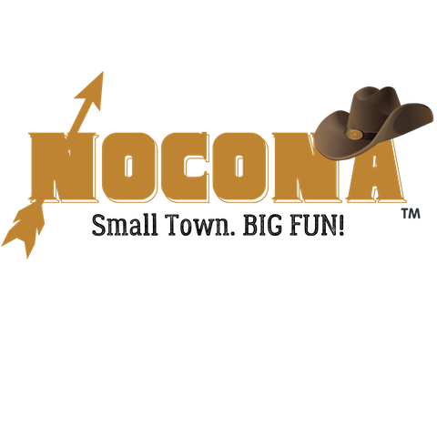
Big Truck, Car, Motorcycle & ATV Show Entry Form
Cruisin’ Nocona
May 4, 2024

Description of Event
WHERE: Historic Downtown, Nocona, TX 76255
WHEN: Saturday, May 4, 2024 ** Registration @ 10:00am - 1:00pm (Voting and Awards to follow)
Price: $25

Application
Name: _____________________________________________________
Mailing Address: ________________________________________________________________
City/State/Zip: _________________________________
Contact Person Name and Phone Number: _____________________________________________
Email: ____________________________
What are you entering? Big Truck Car Motorcycle
Description of Entry: _______________________________________________________
________________________________________________________________________
________________________________________________________________________
________________________________________________________________________

By signing this document, I acknowledge that I assume all risks and complete responsibility for any injury or accident which may occur to myself, my property, or anyone working or attending with me during this event while on the premises. I hereby release and hold harmless the sponsors, promotors, and all persons or entities associated with this event, The Nocona Chamber of Commerce, and the City of Nocona. I understand that the Nocona Chamber of Commerce may refuse any vendor at any time with sole discretion based on our goals to offer a variety of crafts, merchandise, and food types. I grant permission for any photos of me and my booth to be published for advertising purposes.

Signature: _______________________________ Date: __________________________

