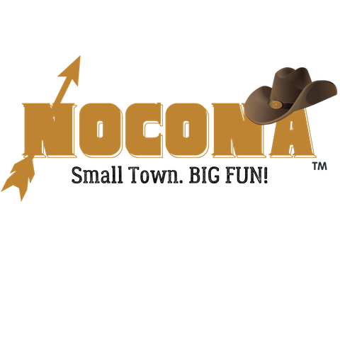
Vendor Registration Form
Small Town Christmas
December 16, 2023 4:30 – Dusk

Description of Event
WHERE: Mary Beckman Davis Park, Historic Downtown, Nocona, TX 76255
WHEN: Saturday, December 16, 2023 ** 4:30 – Dusk
WHAT: Annual Christmas event with parade, hayrides, photos with Santa, face painting, cookie decorating and more!
Application
Name of Organization/Business: _____________________________________________________
Mailing Address: ________________________________________________________________
City/State/Zip: _________________________________
Contact Person Name and Phone Number: _____________________________________________
Email:____________________________ Website or Facebook: _____________________________
Describe specific products you intend to sell or exhibit at this event:
_________________________________________________________________________________
__________________________________________________________________________________
I AM APPLYING TO PARTICIPATE AS A:
Food Truck Vendor (electricity not included)
10 x 20 space (adjoining spaces available)
Vendor Fees are waived for the 2023 year.
Must have valid vehicle registration, motor vehicle operator’s license, proof of liability insurance, hold a Texas Sales Tax Permit, Food handlers’ certificate and compliance with TX Food establishment rules – 25 TAC Sec, 228.
year.

Arts/Crafts/Exhibit/ Food Vendor
10 x 10 space
Vendor Fees are waived for the 2023 year.

Number of spaces requested ______
X above vendor cost ______
Total Due ___0___

Set-up begins at 2:00 pm outside in the park. Must supply table, chairs, canopy.
If weather is an issue, inside space is available.

By signing this document, I acknowledge that I assume all risks and complete responsibility for any injury or accident which may occur to myself, my property, or anyone working or attending with me during this event while on the premises. I hereby release and hold harmless the sponsors, promotors, and all persons or entities associated with this event, The Nocona Chamber of Commerce, and the City of Nocona. I understand that the Nocona Chamber of Commerce may refuse any vendor at any time with sole discretion based on our goals to offer a variety of crafts, merchandise and food types. I grant permission for any photos of me and my booth to be published for advertising proposes.
Signature of vendor: _______________________________ Date: __________________________

