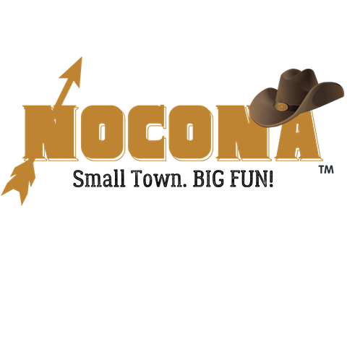
Small Town Christmas
December 21, 2024 10:00 AM

Parade Entry Form

Description of Event
WHERE: Historic Downtown, Nocona, TX 76255
WHEN: Saturday, December 21, 2024 @ 10:00 AM (Line Up at the First Baptist Church at 9:30 AM)

Application
Name of Organization/Business: _____________________________________________________
Mailing Address: ________________________________________________________________
City/State/Zip: _________________________________
Contact Person Name and Phone Number: _____________________________________________
Email:____________________________
What are you entering? Float Car Motorcycle Club Animal Other
If Other, what type? _______________________________________________________
Name of Entry: ___________________________________________________________
Description of Entry: _______________________________________________________
________________________________________________________________________
________________________________________________________________________
________________________________________________________________________

By signing this document, I acknowledge that I assume all risks and complete responsibility for any injury or accident which may occur to myself, my property, or anyone working or attending with me during this event while on the premises. I hereby release and hold harmless the sponsors, promotors, and all persons or entities associated with this event, The Nocona Chamber of Commerce, and the City of Nocona. I understand that the Nocona Chamber of Commerce may refuse any vendor at any time with sole discretion based on our goals to offer a variety of crafts, merchandise and food types. I grant permission for any photos of me and my booth to be published for advertising proposes.

Signature of vendor: _______________________________ Date: __________________________
*Application pending until approved by Executive Director or Nocona Chamber of Commerce Board of Directors.

