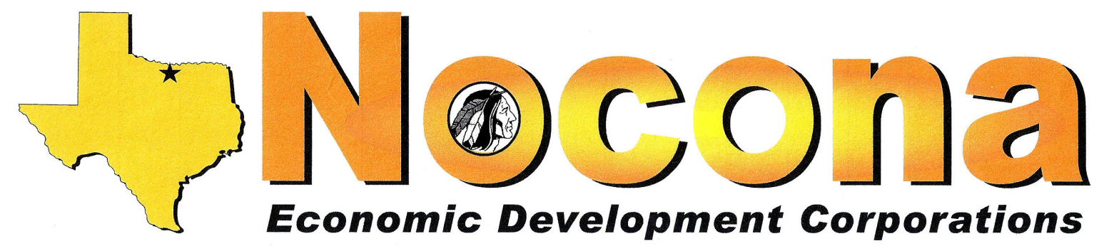
PO Box 494, Nocona TX 76255 (940) 825-3150 noconaedc@nocona.org
Meeting Notice and Agenda
NOTICE IS HEREBY GIVEN THAT
THE GREATER NOCONA AREA ECONOMIC DEVELOPMENT CORPORATION (TYPE A) AND
NOCONA MUNICIPAL ECONOMIC DEVELOPMENT CORPORATION (TYPE B)
WILL HOLD A CALLED SPECIAL JOINT MEETING OF THE BOARDS OF DIRECTORS
Date: Tuesday, October 18, 2016 Time: Noon
Location: Tales 'N' Trails Museum, 1522 E Hwy 82
Agenda items:
- Roll call and call to order: Type A & Type B – Confirm Quorum for Type A & Type B
- CHIEF NOCONA LLC PROPOSAL
- Staff Updates and Travel
  - Fiber Optic Project Update
- Items of community interest
- Adjourn
“The Nocona Economic Development Corporations (Type A & Type B Boards) reserve the right to adjourn into executive session at any time during the course of this meeting to discuss any of the matters listed above, as authorized by the Texas Government Code Sections 551.071 (Consultation with Attorney), 551.072 (Deliberations about Real Property), 551.073 (Deliberations about Gifts and Donations), 551.074 (Personnel Matters), 551.076 (Deliberations about Security Devices), 551.087 (Deliberations regarding Economic Development Negotiations), and 321.3022 (Confidential Sales Tax Information).”In accordance with the Texas Open Meeting Act, this notice will be posted at the Nocona City Hall no later than October 14, 2016.

