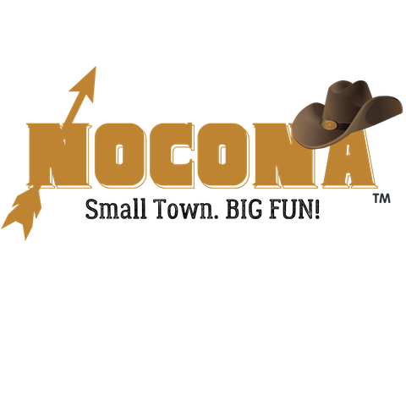
Small Town Christmas
Date: Saturday, December 7, 2024
Vendor Registration Form

Description of Event
WHERE: Clay Street (exact set-up location provided week of event)
WHEN: Set-up at 2:00 PM; Clean-up at 6:00 PM
WHAT: Small Town Christmas: Vendors, Cider Fest, Santa, Shopping and More!
Application
Name of Organization/Business: ________________________________________________________________
Mailing Address: ____________________________________________________________________________
City/State/Zip: ______________________________________________________________________________
Contact Person Name and Phone Number: _______________________________________________________
Email: _________________________________ Website or Facebook: _________________________________
Describe specific products you intend to sell or exhibit at this event:
__________________________________________________________________________________________
__________________________________________________________________________________________
I AM APPLYING TO PARTICIPATE AS A:
Food Truck Vendor
10 x 20 space (adjoining spaces available)
$50 Chamber member
$60 non-Chamber member
Must have valid vehicle registration, motor vehicle operator’s license, proof of liability insurance, hold a Texas Sales Tax Permit, Food handlers’ certificate and compliance with TX Food establishment rules – 25 TAC Sec, 228.
Arts/Crafts/Exhibit Vendor
10 x 10 space (adjoining spaces available)
(table, chairs, canopies supplied by vendor)
$30 Chamber member
$40 non-Chamber member

Number of spaces requested ______
X above vendor cost ______
Total Due ______

Make checks payable to: Nocona Chamber of Commerce, PO Box 27, Nocona, TX 76255

By signing this document, I acknowledge that I assume all risks and complete responsibility for any injury or accident which may occur to myself, my property, or anyone working or attending with me during this event while on the premises. I hereby release and hold harmless the sponsors, promotors, and all persons or entities associated with this event, The Nocona Chamber of Commerce, and the City of Nocona. I understand that the Nocona Chamber of Commerce may refuse any vendor at any time with sole discretion based on our goals to offer a variety of crafts, merchandise and food types. I grant permission for any photos of me and my booth to be published for advertising purposes.
Signature of vendor: _______________________________________ Date: _____________________________
*Application pending until approved by Executive Director or Nocona Chamber of Commerce Board of Directors.

