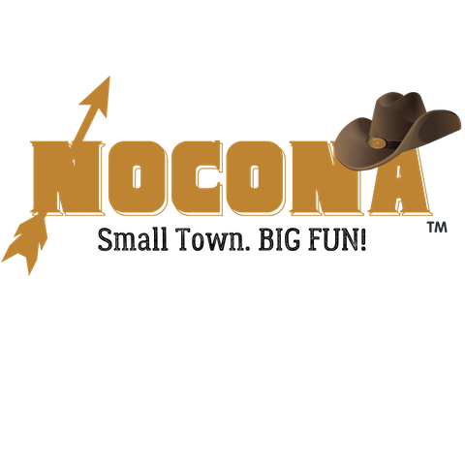
Cruisin’ Nocona
May 4th, 2024 10:00 am
Vendor Registration Form

Description of Event
WHERE: Historic Downtown, Nocona, TX 76255
WHEN: Saturday, May 4th, 2024 ** 10:00 am – 4:00 pm
WHAT: Annual Cruisin’ Nocona Celebration with car show, parade, and more!
Application
Name of Organization/Business: _____________________________________________________
Mailing Address: ________________________________________________________________
City/State/Zip: _________________________________
Contact Person Name and Phone Number: _____________________________________________
Email:____________________________ Website or Facebook: _____________________________
Describe specific products you intend to sell or exhibit at this event:
_________________________________________________________________________________
__________________________________________________________________________________
I AM APPLYING TO PARTICIPATE AS A:
Food Vendor (electricity not included)
10 x 10 space
adjoining spaces available
(table, chairs, canopies supplied by vendor)
$50 Chamber member/Go Texan member
$75 non-Chamber member
Food Truck Vendor (electricity not included)
10 x 20 space (adjoining spaces available)
$80 Chamber member/Go Texan member
$100 non-Chamber member
Must have valid vehicle registration, motor vehicle operator’s license, proof of liability insurance, hold a Texas Sales Tax Permit, Food handlers’ certificate and compliance with TX Food establishment rules – 25 TAC Sec, 228.
Arts/Crafts/Exhibit Vendor
10 x 10 space
adjoining spaces available
(table, chairs, canopies supplied by vendor)
$40 Chamber member/Go Texan member
$50 non-Chamber member

Number of spaces requested ______
X above vendor cost ______
Total Due ______

Make checks payable to: Nocona Chamber of Commerce, PO Box 27, Nocona, TX 76255

By signing this document, I acknowledge that I assume all risks and complete responsibility for any injury or accident which may occur to myself, my property, or anyone working or attending with me during this event while on the premises. I hereby release and hold harmless the sponsors, promotors, and all persons or entities associated with this event, The Nocona Chamber of Commerce, and the City of Nocona. I understand that the Nocona Chamber of Commerce may refuse any vendor at any time with sole discretion based on our goals to offer a variety of crafts, merchandise, and food types. I grant permission for any photos of me and my booth to be published for advertising purposes.
Signature of vendor: _______________________________ Date: __________________________

